Software Specifications Document (SSD)
Entity Enhancement

Profile
Title | Print the line sheet
Tracking # | 130595
Product Line
Module(s) | Inventory Control
Entity Type
Entity(s) | 1
Customer | BAR12 (Barganza)
Date Created | 12/05/2005
Author | Samah Mechael
Date Edited | 12/05/2005
Editor | Samah Mechael
Analysis | Approved By
Analysis | Approval Date |  | MM / DD / YYYY
Conceptual Design | Approved By
Conceptual Design | Approval Date |  | MM / DD / YYYY
Detailed Design | Approved By
Detailed Design | Approval Date |  | MM / DD / YYYY

Table of Contents
Profile 1
Table of Contents 2
Document Sections 3
Versions 3
Vision 4
Stakeholders 4
Needs 5
CFN – Customer Functional Needs 5
CTC – Customer Technical Needs 5
AFN – Aria Functional Needs 5
ATC – Aria Technical Needs 5
ATT – Aria Testing Needs 5
AMT – Aria Marketing Needs 5
ADT – Aria Documentation Needs 5
AST – Aria Supplementary Needs 5
Project Scope 5
1. In/Out Domains 5
2. Project Phases 5
Entity Features 6
User Interface (UI) 6
Option Grid 6
Use Cases 6
UI Rules 7
Option Grid Rules 7
Application Tier 8
Database Design 9
Testing Cases 9

Document Sections
Analysis
Vision
Stakeholders
Needs *
Customer Functional Needs
Customer Technical Needs
Aria Functional Needs
Aria Technical Needs
Aria Testing Needs
Aria Marketing Needs
Aria Documentation Needs
Supplementary Needs
Project Scope
Conceptual Design
Entity Features
User Interface (UI)
Option Grid
Use Cases
Detailed Design
UI Rules
Option Grid Rules
Application Tier
Database Design
Testing Cases
* At least one of the two functional needs sections must be filled.

Versions
Ver # | Date | Modified By | Sections Change Tracking
Ver # | Date | Modified By | New | Deleted | Changed
0.1 | 12/05/2005 | Samah Mechael

Vision
Our customer Burganza Inc. need to get the ability to print the line sheet information of the price , OTS and the Immediate OTS with the style picture

Role | Category | Description | Comments
Any Area user | Regular User

Needs

CFN – Customer Functional Needs
Burganza needs to print the line sheet for the styles using the same option grid for the style summery report

CTN - Customer Technical Needs
The customer needs to be sure that the styles’ pictures are entered and displayed correctly from the style screen

AFN – Aria Functional Needs

The report will give the option either to print the standard style summery report or the line sheet report

If the user select to print the line sheet report, they will have to option to select only 1 transaction to be printed

Same styles from the criteria of the standard style summery report will be printed in the output for the line sheet report

Will print 4 styles in each page unless one of the styles has a lot of colors , it can float to the next page

ATN – Aria Technical Needs

A layout of the report for the line sheet option is attached
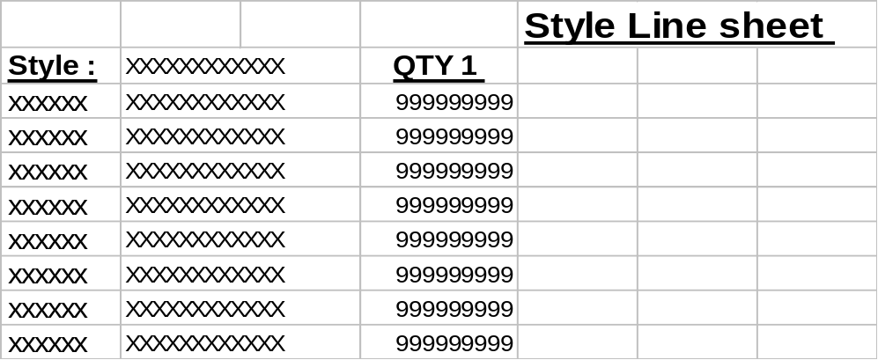

Option Grid

We will use the standard option grid for the style summery report and we will add a new option to check if printing the regular style summery or the line sheet
# | Item | Operator | Value
1 | Standard option grid for the style summery report
2 | Print | Equal | Standard report or Line sheet

*********added by MHM
1 - regarding to Samah's Spec. we'll deal with OTS and IMM.OTS only or all transaction but the user will select only one.
We will deal with all option

2 - what about the sorting option . that because in the standard report every one of sorts has a report form with a separate frx.
Sorting will apply but no change in the layout

Price ----- Style PriceA
Qty1-------Total Qty

